**8 BIT ADDITION:**

**CODE:**

LDA 2500

MOV B,A

LDA 2502

ADD B

STA 2504

HLT

**OUTPUT:**

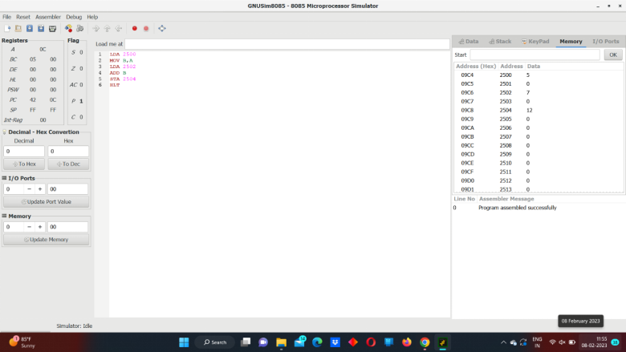

sss